OOP Lab: Experiment 5

Submitted By: Aryan Saxena

Batch: B1

SAP Id: 500082431

Roll No.: R214220274

**Exercise 1:** Write a program to create interface named test. In this interface the member function is square. Implement this interface in arithmetic class. Create one new class called ToTestInt. In this class use the object of arithmetic class.

Code:

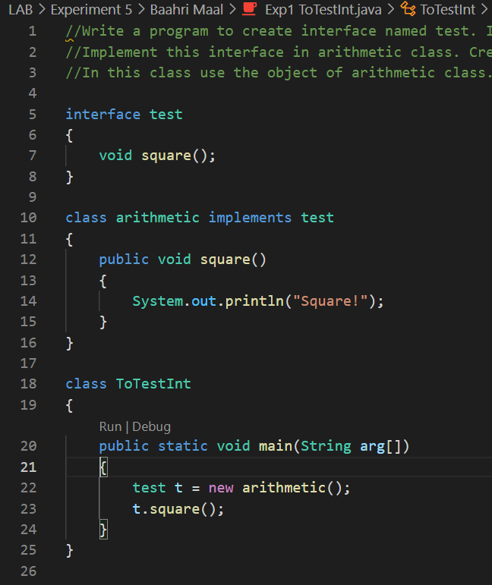

## Output:

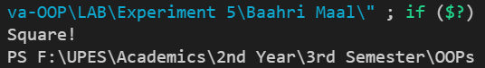

**Exercise 2:** Write a program to create interface A, in this interface we have two method meth1 andmeth2. Implements this interface in another class named MyClass.

## Code:

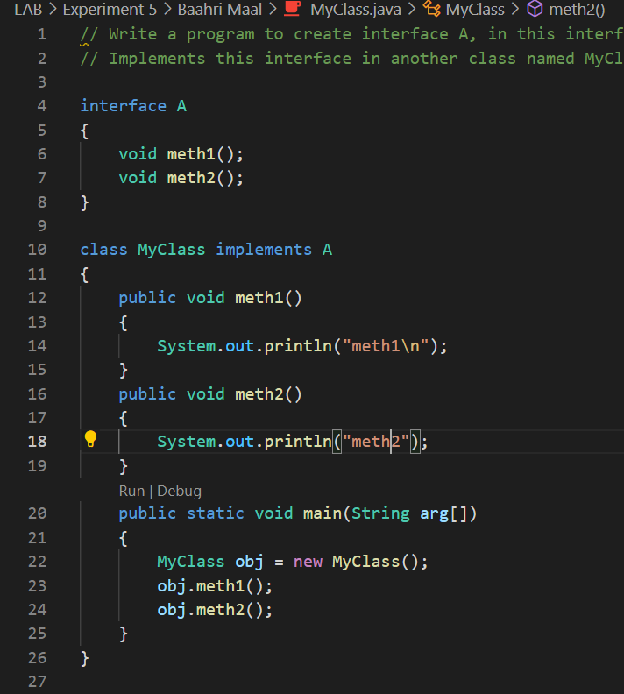

## Output:

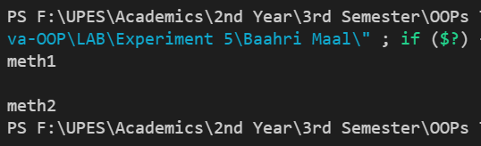

**Exercise 3:** Write a program in Java to show the usefulness of Interfaces as a place to keep constant value of the program

## Code:

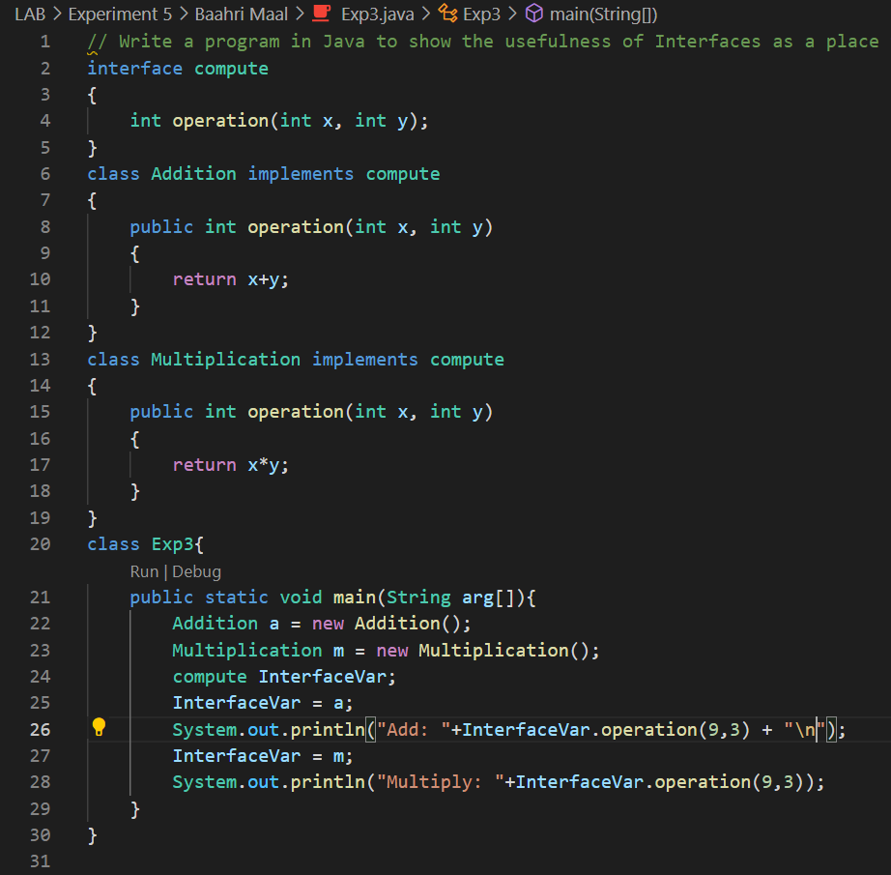

## Output:

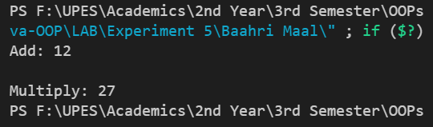

**Exercise 4:** Write a program to create an Interface having two methods division and modules. Create a class, which overrides these methods.

## Code:

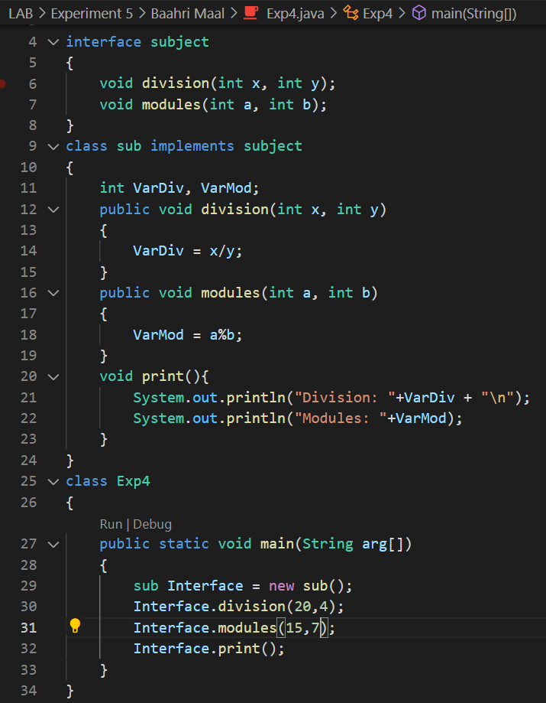

## Output:

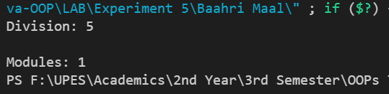

**Exercise 5:** Write program to create an interface Stack Interface having methods push (), pop ()and display (). Stack Class implements Stack Interface. Class Stack Class contains the main method which is having a switch case for selecting the particular operation of the stack.

## Code:

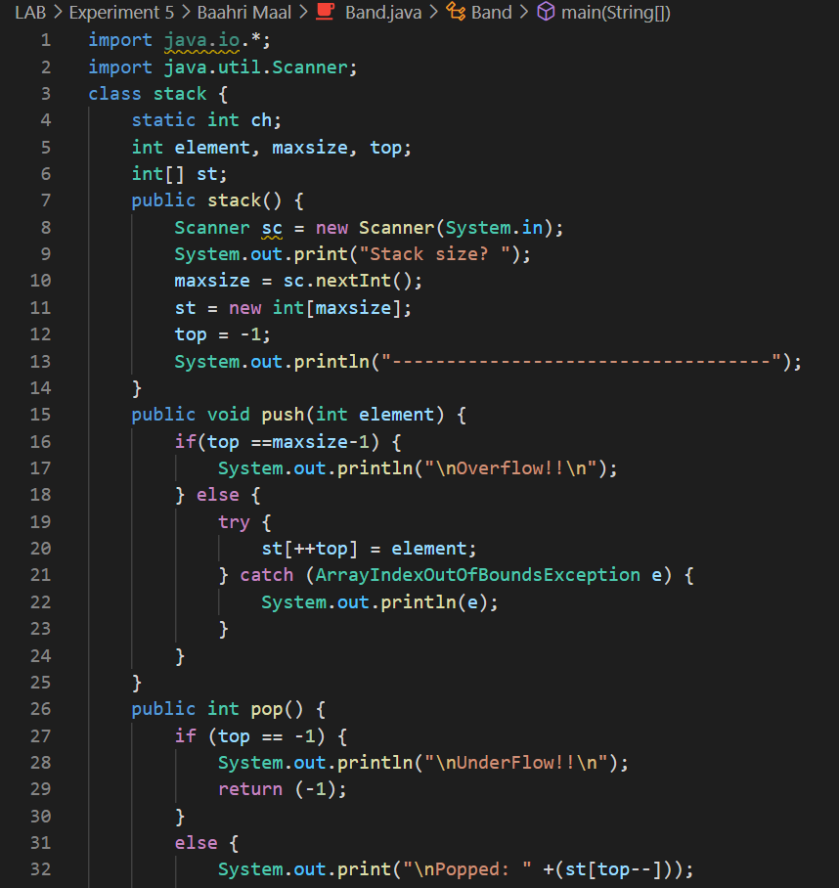

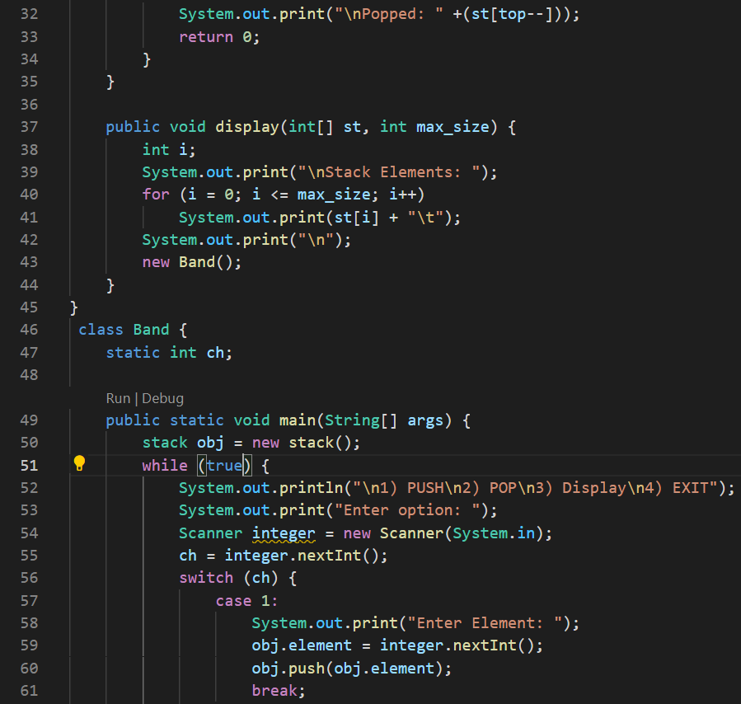

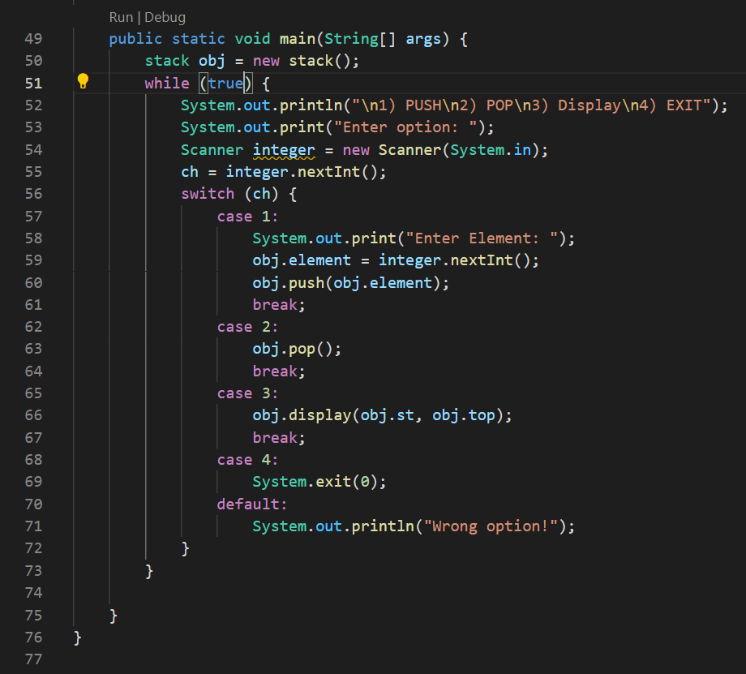

## Output:

